# Code Review Checklist

* All methods are commented in clear language. If it is unclear to the reader, it is unclear to the user.
* **All source code contains description** (especially method in Object class).

Ex:

|  |  |
| --- | --- |
| Test class |  |
| **Object class** |  |

* All class, variable, and method modifiers should be examined for correctness.
* Confirm that the code does not depend on a bug in an external framework which may be fixed later, and result in an error condition. If you find a bug in an external library, open an issue, and document it in the code as necessary.

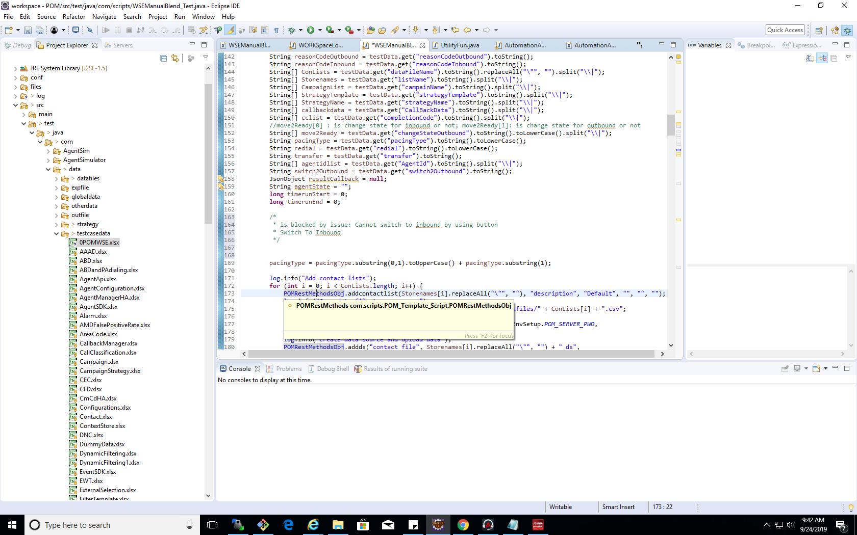EX: add message that this code is blocked by what issue

* Incomplete code is marked with //TODO or //FIXME markers.
* All public and private APIs are examined for updates.
* Objects are duplicated only when necessary. If you must duplicate objects, consider implementing Clone and decide if deep cloning is necessary.
* No busy-wait loops instead of proper thread synchronization methods. For example, avoid while(true){ ... sleep(10);...}
* Avoid large objects in memory, or using String to hold large documents which should be handled with better tools. For example, don't read a large XML document into a String, or DOM.
* Do not leave debugging code in production code.
* Avoid System.out.println(); statements in code, or wrap them in a Boolean condition statement like if(DEBUG) {...}

# Prepare code for review

* Just sent code that is modified or created.
* Copy only method that be created or modified (include new element, library,... ).
* Named for this file by the same with the name of the page.

**Ex:**

Create new method in page WORKSpaceLogin.java.

Copy only method that be created (include new element, library,... ).

Named for this file is WORKSpaceLogin.java.